Student Name: Student ID:
(Family Name), (Given Name)

Griffith University

School of Information Technology

3403INT (INTERNET) - Workflow Management Systems

Semester 2 - 2005 End of Semester

WORKING TIME: 3 Hrs 00 Mins

PERUSAL TIME: 15 Mins

EXAMINATION TYPE: Closed Book

PERUSAL INSTRUCTIONS: During perusal students may write only on the Examination Paper

EXAMINATION INSTRUCTIONS TO STUDENTS:

N/A

STUDENTS ARE PERMITTED TO BRING THE FOLLOWING MATERIALS INTO THE EXAMINATION VENUE:

CALCULATOR: Open calculator

DICTIONARY: Open Dictionary (but no electronic dictionaries)

OTHER MATERIALS ALLOWED: Learning Journal of no more than 33 single sided printed pages
and using a regular 12 point font (e.g., Times New Roman 12 point)
and not including any image nor exercise solution.

THE FOLLOWING MATERIALS ARE SUPPLIED BY GRIFFITH UNIVERSITY:

14 PAGE ANSWER BOOK: 1

THIS EXAMINATION PAPER MUST NOT BE REMOVED FROM THE EXAMINATION VENUE.

Paper Number: 871
Question 1 (1.5 point; hence, the time allowance for this question is 27 minutes)

Compared to a traffic light in Australia, a traffic light in Germany has an extra phase in its cycle: the traffic light does not turn suddenly from red to green but, besides a red light, also gives a yellow light just before turning to green.
a) Using solid lines, draw a Petri net that “may” behave like a German traffic light.
There should be three places indicating the state of each light and all state transitions of the
transition system should be supported. (0. 75 point)
b) Using dashed lines, add places and/or transitions to your Petri net so that always behaves “exactly” like a German traffic light. List the potential anomalies that are avoided by this addition of places and/or transitions. (0.25 point)
c) Represent your resulting Petri net in PNLF using a maximum of 5 lines. (0.5 point)
Indent correctly.

Question 2 (1.25 point; hence, the time allowance for this question is 22.5 minutes)

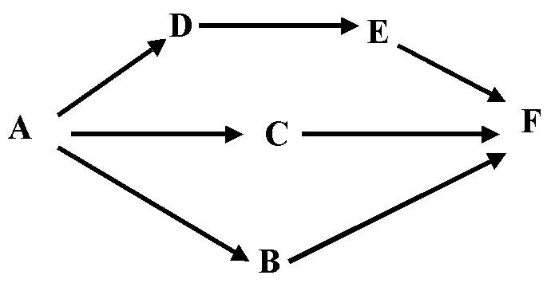
Consider a project consisting of six tasks: A, B, C, D, E, F that are to be undertaken by one person. The following figure specifies the order in which the tasks need to be executed. A possible execution trace is A B D C E F.

a) Using solid lines, draw a (classical) Petri net for this project. (0.25 point)
b) Using dotted lines, add something to your Petri net so that E becomes optional. (0.1 point)
c) Using dashed lines, add something to your Petri net so that the tasks D and E
are executed consecutively (that is, the execution of tasks B and C are not allowed
between tasks D and E). (0.3 point)
d) Represent your resulting Petri net in PNLF using a maximum of 6 lines. (0.6 point)
Indent correctly.

Question 3 (0.75 point; hence, the time allowance for this question is 13.5 minutes)

List three errors that the following model has.
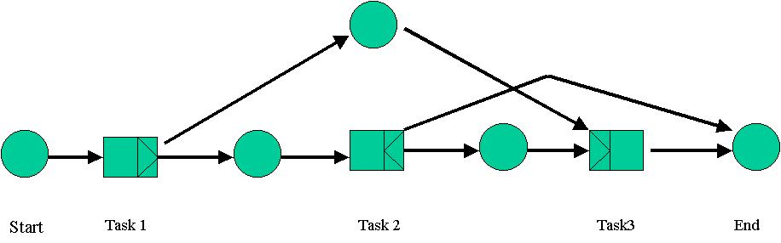
Question 4 (1.5 point; hence, the time allowance for this question is 27 minutes)

Consider the description of the following (binary) counter. The marking of a place represents a binary value (1 or 0). The combination of the markings of the places represents the natural number that is displayed by the counter. For example, the binary number 101 (i.e., 5) marks two places corresponding to a “1” (i.e., the places 2² and 2⁰) and one place corresponding to a “0” (i.e., the places 2¹). Draw a Petri net model of a counter able to count from 0 to 7.

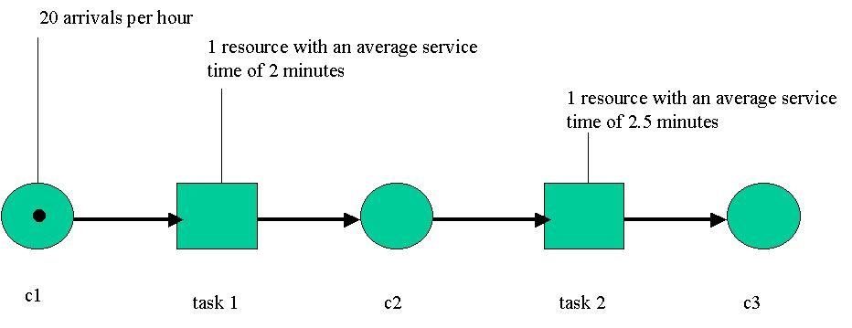
Question 5 (1.5 point; hence, the time allowance for this question is 27 minutes)
a) Based on the above model, calculate the following performance indicators:
- the resource’s utilized capacity (use “r1” for the 1st resource, “r2” for the second resource),
- the average number of cases in progress (use “L1” for the 1st task, “L2” for the 2nd task, and
“Lt” for the total),
- the average waiting time (i.e., completion time minus processing time; use “W1” for the 1st task,
“W2” for the 2nd task, and “Wt” for the total),
- the average system/total time (i.e., waiting time plus processing time; use “S1” for the 1st task,
“S2” for the 2nd task, and “St” for the total).
Assume that processing time and case inter-arrival times are distributed in a negative exponential way. Show your calculations and give the formulas for each indicator (use the variable “n” for the number of new cases that need to be processed by one resource, and the variable “u” for the
number of cases completed per time unit). (0.75 point)

b) Task 2 is a check task. The management is considering a selective execution of this task where only 25% of the cases are to be checked. The average service time for this new task is 6 minutes. Recalculate all the above cited performance indicators. Show your calculations. (0.75 point)

Question 6 (1.25 point; hence, the time allowance for this question is 22.5 minutes)

Consider the following Petri net. The weight (“2”) on the arc from p3 to t5 implies that t5 consumes two tokens at a time (in other words, it cannot be fired if there is only one token in p3).
a) Give the reachability tree of this Petri net. (0.5 point)
b) Can you conclude from this tree that this Petri net is bounded or not, live or not, sound or not,
safe or not? When you can conclude, give the answer and explain it very quickly. In any case,
give a quick definition of boundedness, liveness, soundness and safety (to simplify, you are
allowed to refer to the reachability tree of a Petri net in your definition, and then conclude for
the following Petri net based on your reachability tree). (0.5 point)
c) Explain why you could or could not have used the “method based on combining safe and
sound building blocks” in order to prove the boundedness, liveness, soundness and safety of
this Petri net. (0.25 point)
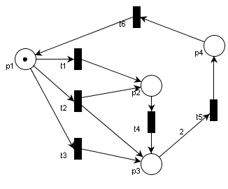

Question 7 (0.75 point; hence, the time allowance for this question is 13.5 minutes)

In workflow management, choices must be continually made in the allocation of work items to the available resources.
a) Define the two ways this can be done. (0.25 point)
b) Can the two ways be used in combination? Explain your response. (0.5 point)

Question 8 (1.5 point; hence, the time allowance for this question is 27 minutes)
Using the notation that you used for the semi-formal summaries, represent:
a) 4 specializations, 3 parts, 1 method and 1 tool of “process_management” (0.25 mark)
b) 1 generalization, 1 informal definition, 3 synonyms, 3 specializations
and 1 agent of “WF_process” (0.25 mark)
c) 8 specializations of “WSF_element” (0.2 mark)
d) 1 generalization and 3 specializations of “WF-net” (0.2 mark)
e) 1 generalization and 3 parts and 1 description of “hierarchical_organization” (0.2 mark)
f) 8 specializations of “process_characteristic” (0.2 mark)
g) 1 informal definition for each of the 8 process characteristics (0.2 mark)
Do not represent the source/author of each relation. Indent correctly.

END OF EXAM

